Ian Moulton & Ani Vemprala

STAT 701

Predicting Congressional Bills Project

Literature Review

“Predicting Congressional Bill Outcomes”[1]

* “We had to parse through the roll calls to find only those roll calls that involved voting a bill into law.” (2)
* “To eliminate unhelpful tokens, we calculated the inverse document frequency (idf) scores for all tokens.” (3)
* “We began treating not present votes as no votes for all our training and test data.” (4)

“Textual Predictors of Bill Survival in Congressional Committees”[2]

* “Roughly 85% of bills do not survive committee. By contrast, nearly 90% of bills that are recommended by a committee (i.e., survive the committee are introduced for debate on the floor) will survive a roll call vote by the legislature.” (1)
* This article considered the following congressional bill features (3 – 4):
  + 1. For each party p, is the bill’s sponsor affiliated with p?
  + 2. Is the bill’s sponsor in the same party as the committee chair? Equivalently, is the bill’s sponsor in the majority party of the House?
  + 3. Is the bill’s sponsor a member of the committee?
  + 4. Is the bill’s sponsor a majority member of the committee? (This feature conjoins 2 and 3.)
  + 5. Is the bill’s sponsor the chairman of the committee?
  + 6. For each House member j, did j sponsor the bill?
  + 7. For each House member j, is the bill sponsored by j and referred to a committee he chairs? (This feature conjoins 5 and 6.)
  + 8. For each House member j, is the bill sponsored by j and is j in the same party as the committee chair? (This feature conjoins 2 and 6.)
  + 9. For each state s, is the bill’s sponsor from s?
  + 10. For each month m, is the bill introduced during m?
  + 11. For v {1, 2}, is the bill introduced during the vth the year of the (two-year) Congress?
* Also, the following chart details the most significant words from the bag of words analysis:

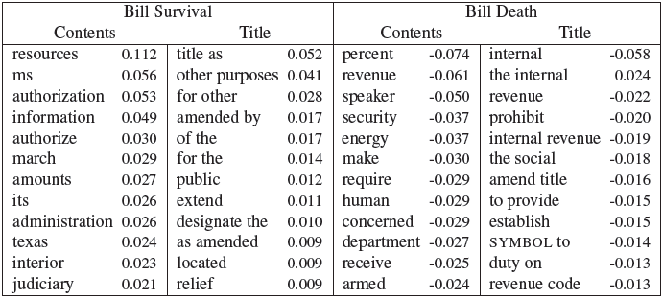

“Predicting Congressional Swing Voters”[3]

* “the importance of [bill] types is minimal.”
* “Based on the number of swing congressman needed to pass a bill, a tradeoff of dollars versus reliability of swing can be made . . . It is possible that ‘buying’ a congressman causes other congressman to join onto the bill as well.”
* “For each Congressman A, we have gathered the number of times Congressman A agrees with Congressman B and the total number of bills A and B both voted on.” (ppt slide 15/17)

“Statistical prediction of bill passage success”[4]

* GovTrack also looks at:
  + “if any cosponsor is the chair or ranking member (most senior minority member party member) of a committee the bill has been referred to”
  + “if there are 3-5 cosponsors of the bill serving on a committee the bill has been referred to”
  + “if the bill has a cosponsor from both parties”

“Predicting Congressional Votes Based on Campaign Finance Data”[5]

* “We validate that the campaign donations of politicians are mainly influenced by his or her political power and affiliation to a political party.” (1)
* “We show, for the first time, a strong correlation between donations and votes.” (1)
* Variables include: “publicly stated positions on various bills by various corporations and interest groups.” (2)

1. http://cs229.stanford.edu/proj2012/CainChuaGampong-PredictingCongressionalBillOutcomes.pdf
2. http://projects.iq.harvard.edu/ptr/files/yanosmithwilkersonbillsurvival.pdf
3. http://predcongressvoters.blogspot.com
4. http://legalinformatics.wordpress.com/tag/statistical-prediction-of-bill-passage-success/
5. http://www.mariofrank.net/paper/2012ICMLA_PredictingVotes.pdf